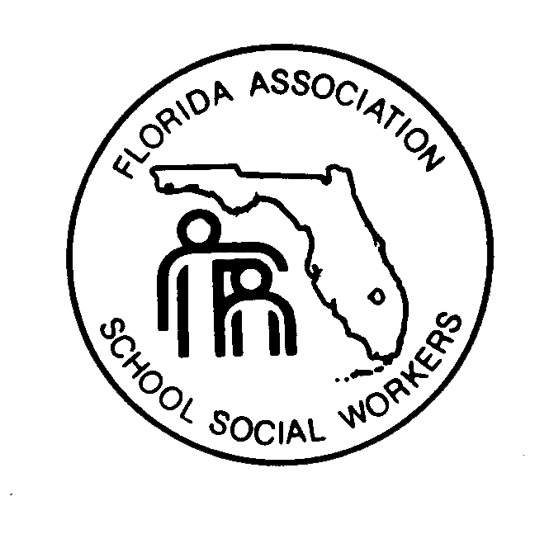
FLORIDA ASSOCIATION OF SCHOOL SOCIAL WORKERS

RUTH ANNE ST. JOHN SCHOLARSHIP APPLICATION FORM
(Please print or type)

Applicant’s Name:_______________ _____________________ _____ ______
Last First MI Age
Home Address: ______________________ _________________________ ________
Street City, State Zip
Telephone:( )__________________

Are you currently enrolled in an Master’s of Social Work program as a clinical level or advanced standing student? __________________

Name of Graduate School ________________________________________________
Are you currently assigned to complete a field internship in a public or private school in the state of Florida? _____________

If yes, list the location of Field Placement: _____________________________________________________________________
County and School
Field Instructor’s Name: ________________________________________________

Are you receiving any financial aid? ________ If yes list type(s)
_______________________________________________________________________
Estimate yearly family income: $___________

List the number of persons in your immediate family. __________

Are family members able to contribute to your educational expenses? ________

If yes, approximately how much: $__________________

What are your anticipated total educational costs? $____________________

Are you employed? _______ If yes, where?____________________________________

How many hours a week do you work? __________

What is your planned area of concentration?__________________________________

Thank you for completing this application. The Scholarship Committee.
Email this form and all required items by October 10, 2016 to: Amber DeMorse, MSW at fasswscholarships@gmail.com

