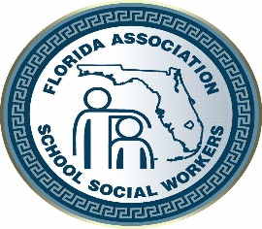
2021 FASSW CONFERENCE
REQUEST FOR PROPOSAL
WORKSHOP PRESENTER PROPOSAL FORM

The Florida Association of School Social Workers (FASSW) Conference Program Committee is now accepting workshop proposals for presentations at the 74th Annual FASSW State Conference hosted by the FASSW Executive Board and Orange County School Social Workers. The conference will be held at the DoubleTree By Hilton Orlando at SeaWorld – Orlando, Florida October 6 - 8, 2021. The 2021 conference theme is:

“Moving Beyond Surviving To Thriving:
Practical Interventions To Improve Your Practice”

We invite school and community social workers, mental health professionals and organizations in related fields to submit a workshop proposal for participation consideration. This year’s Conference will focus presenting workshops to enhance and expand practical interventions to help student thrive.
Deadline to submit is August 30, 2021!

Presentation Title
Please select availability for presentation:
Wednesday, October 6th ☐ a.m. ☐ p.m. ☐ both
Thursday, October 7th ☐ a.m. ☐ p.m. ☐ both

Presenter Information:
Complete all information for each presenter in the order you want it to appear in the program listing. Use separate sheets as needed, typewritten information only. Attach a brief bio‐sketch for each presenter, including experience and qualifications, not to exceed 25 words. If selected, the information provided will appear in the conference booklet as submitted on this form and attachments. Please include presenter’s names on all attachments.

Presenter’s Name: |  |  |  | Credentials:
Job Title: |  |  |  | Employer:
Preferred Mailing Address:
Contact Number: |  |  |  | Contact E-mail:

Please email form to fasswpresident@gmail.com

Note conditions/liabilities indicated below:
We regret to inform you that presenters will not receive any compensation for their presentation unless otherwise arranged in writing. Hotel, travel and other expenses, such as handouts are the sole responsibility of the presenters. Presenters are required to register for the State Conference at the Presenter Rate if they wish to attend other activities. The program conference committee reserves the right to change the length and format of the presentation after notification has been provided. Only the first named presenter will be notified of proposal acceptance. Your presentation may be selected for consideration as a CEU workshop. Submission of Request for Speaker Proposal Form acknowledges acceptance of these conditions and limitations.
2021 FASSW Conference

“Moving Beyond Surviving To thriving:
Practical Interventions To Improve Your Practice”

With A Focus On: Beyond Surviving: Reviving and Thriving Mental Health – Adverse Childhood Experiences (ACE) – Social Emotional Learning (SEL) – Implicit Bias
Presenter Workshop Proposal Information
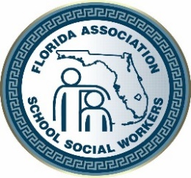
Presenter(s)
Presenter’s Name:
Organization:
Position/Title:
Co-Presenter’s Name:
Organization:
Position Title:
Presentation Format
General Topic:
Content Focus Area:
 | Adverse Childhood Experiences |  |  |  |  |  |  |  |  |  |  | Mental Health |  |  |  |  |  |  |  | Social Emotional Learning |  |  |  |  |  | Implicit Bias
Presentation Style:
 | Lecture |  |  | Lecture plus Interactive Activities |  |  |  |  |  |  |  |  |  |  |  | Out of Seat Activities |  |  |  |  |  |  |  | Panel Discussion |  |  |  | Other
Target Audience: |  |  |  |  |  |  |  | Elementary |  |  |  |  |  | Middle |  |  |  |  |  |  |  | High
Audio/Visual Needs
Please check the audio/visual items needed from FASSW for your presentation:
 | Laptop |  |  |  | Projector |  |  |  |  |  | Extension Cord |  |  |  |  |  |  |  | Other:
Learning Outcome/Objectives:
Objective #1:
Objective #2:
Objective # 3:

Abstract
Please type a brief abstract of your presentation in 75 typed words or less
Presentation Title:
Presenter(s):
fasswpresident@gmail.com
813.644.2145

