FASSW 73rd Annual State Conference
October 16 - 18, 2019
Embassy Suites Fort Lauderdale, Florida
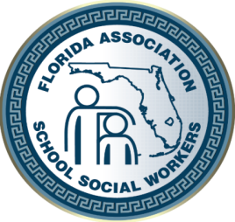

“Helping Students Since 1942”

Dear Prospective Presenter,
The Florida Association of School Social Workers (FASSW) will present its 73rd Annual School Social Work Conference October 16 – 18, 2019 at the Embassy Suites Fort Lauderdale, Florida. FASSW’s 73rd Annual Conference theme is: MENTAL HEALTH STRATEGIES FOR STUDENT ENGAGEMENT AND ACADEMIC SUCCESS.
We are expecting school social workers from throughout the state of Florida to attend. To help enhance our clinicians’ practice we are planning to highlight available resources and services of our partners working with children and their families.

We are extending an invitation for you to join our conference as a prospective workshop presenter. The conference will offer two full days of workshops for attendees. Please complete the attached information and return by August 30, 2019 for consideration.
Thank you for your immediate attention to this matter and thank you for your participation as School Social Workers gather to enhance our practice and work to meet the needs of children and families.
If you have any questions, please contact me at: FASSWConferenceChair@gmail.com.

Sincerely,
Lynette Judge, MSW
FASSW State Conference Chair

