**Welcome to the 72nd FASSW Conference**

**Message from the FASSW President**

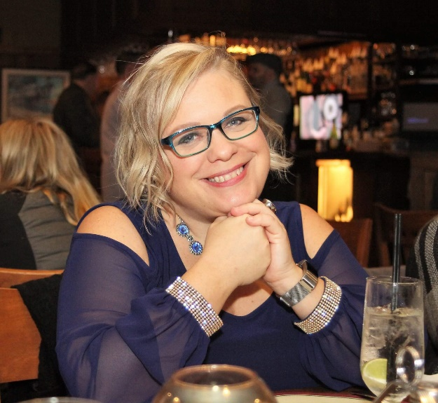

The FASSW Board, Conference Chair, and the Conference Committees have been working diligently to put on an astounding conference to grow our craft, share our expertise and network with extraordinary professionals.

This year has presented many challenges, including the inexplicable losses in Parkland. On behalf of FASSW, we would like to recognize all the school social workers and professionals who participated in the recovery and healing of those impacted by the Marjory Stoneman Douglas High School shooting. As difficult as our jobs may be at times, we continue to serve our communities with excellence.

We have also experienced positive changes this year with the Senate Bill 7026, “Marjory Stoneman Douglas High School Public Safety Act,” resulting in the hiring of additional school social workers in many districts across the state.

FASSW continues to advocate for our profession and build bridges with other associations. This summer FASSW teamed up with Florida Association of School Psychologist and Florida School Counselor Association in creating a position statement. In addition, FASSW Vice President participated in the School Social Work Association of America’s Delegate Assembly that was held in Charleston, South Carolina.

Most recently, I was asked to represent FASSW on the School Health Services Program Ad Hoc Advisory Committee. As a member of this committee, we will be reviewing the current School Health Services Program, and making recommendations based on best practices and initiatives. I look forward to proudly representing our Association and sharing more information in the future.

Lastly, some of you may have noticed our new website. We will be using the newly designed website to facilitate webinars as well as continue to build communication and collaboration with our members. We are always looking for volunteers to assist with the website maintenance and tech support.

Thank you for being here with us and enjoy the conference.

**Karie M. Johnston, LCSW**  
FASSW President

MESSAGE FROM THE CONFERENCE CHAIR

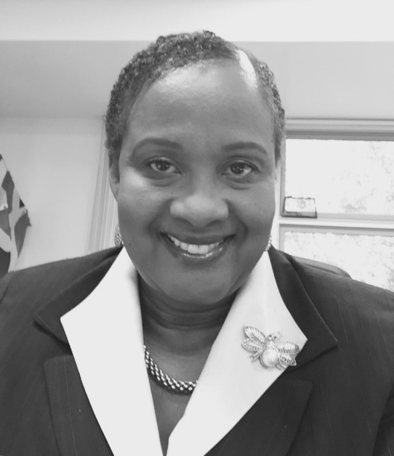It has been an honor to serve the FASSW in this capacity as we worked diligently to provide our members with an excellent professional learning experience. We carefully selected best practices from around the State, and nationally, to share with you, and engaged content experts to bring cutting-edge information to be added to our bulging professional toolkits. Heartfelt thanks to the FASSW Executive Board and all members of the conference planning committee. Special thanks to the Hillsborough County School Social Work Supervisor and staff for leading the charge, and huge thanks to Orange, Polk and Pasco Counties for your fine support!

**Laurel E. Thompson, Ph.D.**

FASSW Conference Chair

**CONFERENCE COMMITTEE MEMBERS**

Program – Ms. Peggy Smith

Budget – Ms. Beverley Wilks

CEU – Dr. Freddie Nieves

Entertainment – Ms. Lutcharde Darius

District Conference Chair – Ms. Lynette Judge

Bea Scott, Melissa Schultz, Danica Cockrell, Martha Rodriguez Rivera

Alisha Brill, Angela Weck, Crystal Leach, Denise Sepulveda, Esperanza DeJesus

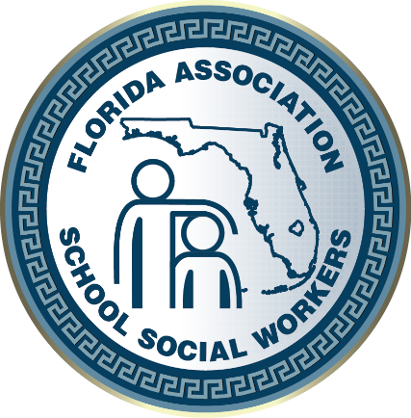

**THANK YOU FROM THE FASSW EXECUTIVE BOARD**

President: **Karie Johnston**, Orange County

Immediate Past President: **Liliana Pardo-Posse**

Vice-President: **Marisa Kinney**, Broward County

Treasurer: **Beverley Wilks**, Seminole County

Secretary: **Katie Mitchell-Gregory**, Pasco County

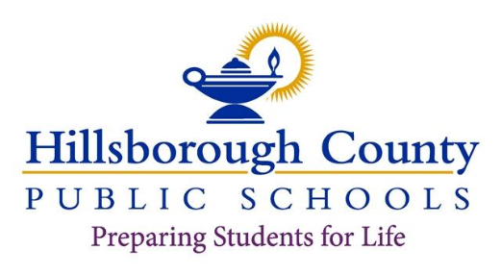

**Superintendent of Schools**

Jeff Eakins

**Deputy Superintendent, Instructional**

Van Ayres

**Deputy Superintendent, Operations**

Christopher Farkas

**Chief of Schools, Administration**

Harrison Peters

**School Board**

Sally A. Harris, Chair

Tamara P. Shamburger, Vice Chair Lynn L. Gray

April Griffin Melissa Snively Cindy Stuart Susan L. Valdes

September 24, 2018

School Social Workers,

As Superintendent of Hillsborough County Public Schools, it is my pleasure to welcome you to the Florida Association of School Social Worker's 72nd Annual Conference.

Serving as mental health professionals, School Social Workers are essential in providing clinical support for students through a trauma-focused lens. Our schools must continue to be safe places where students are engaged and supp01ied as they work towards becoming productive citizens.

My guiding principle as Superintendent is based on the belief that when we set the right conditions for students, and when they operate from an equal level playing field, they will succeed. I know that you care about each and every student, build productive and sustainable relationships with students and families, and advocate for the entire student population. Your positive impact truly makes a difference.

I hope that your visit to Hillsborough County and your participation in the FASSW Conference will enhance your skill set and energize you. When our students succeed, our schools succeed, and when our schools succeed, our communities thrive.

Thank you for all you do to Prepare Students for Life.

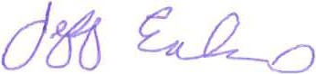 Sincerely,

Jeff Eakins Superintendent

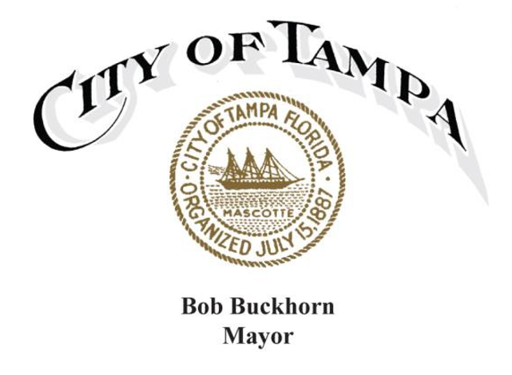

Greetings,

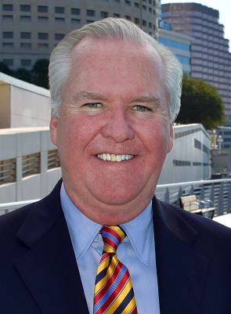It is a pleasure to welcome all those attending the **Florida Association of School Social Workers’ 72nd Annual Conference** in Tampa, Florida on October 24-26, 2018. This event held at the Holiday Inn Westshore Hotel features the theme ***Clinicians Advocating for Student Wellness, Success & Safety***. Tampa is honored to have been selected once again for this important conference.

The Florida Association of School Social Workers (FASSW) was established in 1942, and its mission is to promote the profession of school social work and enhance the professional growth and development of school social

workers throughout the state of Florida in order to more effectively meet the needs of all children. This comprehensive conference provides the opportunity to gain valuable knowledge and improve social work services in the Florida school system, and includes keynote speaker Dr. Robert Lucio, Professor at St. Leo College, an exclusive screening of the film “*Listen*” with a discussion following with the writer and director Erahm Christopher, and informative sessions on important topics.

For those visiting Tampa for the first time, we hope you will have the opportunity to experience the numerous cultural, historical and entertainment attractions our city has to offer. Of particular note are Historic Ybor City and the Tampa Riverwalk which connects the Tampa Bay History Center, The Florida Aquarium, Tampa Museum of Art, Glazer Children’s Museum, Curtis Hixon Waterfront Park, Water Works Park and the newly renovated Julian B. Lane Riverfront Park, and the Perry Harvey, Sr. Park, all state-of-art facilities honoring our community’s history and rich heritage.

Again, welcome and best wishes for an enjoyable and productive time.

Sincerely,



Bob Buckhorn

**FASSW Remembers Delia P. Sanchez:**

**A Champion Clinician Who Tirelessly Advocated for Student Wellness, Success and Safety**

[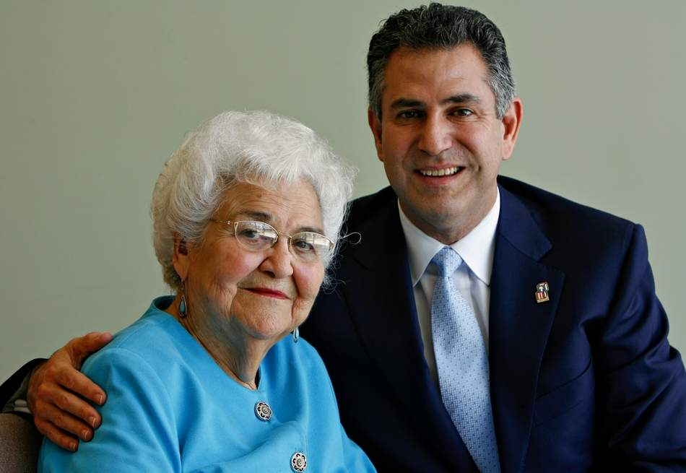](https://www.tampabay.com/storyimage/HI/20180818/ARTICLE/308189717/AR/0/AR-308189717.jpg?MaxW=2000&cachebuster=675653)

During this, our 72nd Annual State Conference, the FASSW Board has decided to honor Delia Sanchez with a special remembrance in recognition of her contributions to the legacy of our Association and to the Hillsborough community. Born in Tampa on December 4, 1924, she died this past August 18th in the city where she was known lovingly as the “Mother Teresa of Tampa” (see link below)

During her remarkable 93 years of life she devoted the majority of her adult life in productive endeavors that will most certainly continue to be a lasting legacy to many on a local, state and national level.

An Ybor City native and the daughter to Spanish immigrants, Delia Sanchez attended Florida State University when it was still a women’s college. She got her master’s in social work from Columbia University, New York City, in 1947. She served as the first MSW school social worker in Hillsborough County Public Schools, was later a SSW Coordinator and retired as the Supervisor of Head Start with the school district.

Delia Sanchez also worked closely with Providence Velasco to develop Student Services at the Hillsborough school district. In their honor, each, respectively, have school buildings named in their honor, the Providence Velasco Building, and the Delia Sanchez Full Service Center in East Tampa.

As part of our FASSW legacy, both she and Providence Velasco were among the early founders of our State Association. In 1951 it was known as the *Visiting Teachers and Attendance Assistants Section of the Florida Education Association.* As her mentor Providence Velasco did earlier (1946 & 1947, 1951 & 1952), Delia Sanchez served in 1958 as the VT/SSW state leader (now FASSW President). They believed strongly in professional development, service delivery and advocacy. That philosophy of service continues to this day and is a vital part of our FASSW mission.

On another related level both of these early SSW leaders led a federal grant in the Hillsborough school district which provided the resources that helped develop more services for students, including school psychology and guidance services. It served as an early state model for the current day student support team now part of every public school. She also worked alongside Congressman Sam Gibbons to bring Head Start to assist low-income preschool-aged children, to Hillsborough County before anywhere else. The way she ran the still-existing program back in 1965 became the blueprint for the nation.

During her lifetime she was honored for her leadership and dedication in many areas. Her honors are too numerous to list here, (see online links below for more information) but among a few are: the Hispanic Heritage Inc.’s *Hispanic Women of the Year*; University of South Florida, School of Social Work *Honorary Doctorate Degree*, and recognition by U.S. Representative Kathy Castor in a Congressional speech on the floor of the House of Representatives during Women’s History Month in 2008.

FASSW is extremely proud to count Delia Sanchez as a school social work colleague and Association founder and welcomes the opportunity to acknowledge her influence on our profession.

For further information on Delia Sanchez’ remarkable life and legacy please click on the links below:

* <https://www.tampabay.com/news/education/k12/Epilogue-Tampa-s-Mother-Teresa-Delia-Sanchez-remembered-as-child-welfare-champion_171009884>
* <https://castor.house.gov/news/documentsingle.aspx?DocumentID=87389>
* <https://www.tampagov.net/sites/default/files/proclamations/20180822_in_memoriam_delia_p._sanchez_0.pdf>

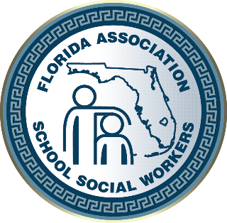

**2018 CONFERENCE AT A GLANCE**

**Wednesday (10/24/18)** **PRE-CONFERENCE**

8:00 a.m. – 4:30 p.m. Registration (King Palm)

9:00 a.m. – 12:00 noon **Pre-Conference Workshop – AM Session** (Royal Palm 3-5)

10:30 a.m. – 10:45 a.m.BREAK

12:00 p.m. – 1:30 p.m. LUNCH (***on your own***)

1:30 p.m. – 4:30 p.m. **Pre-Conference Workshop – PM Session** (Royal Palm 3-5)

3:00 p.m. – 3:15 p.m. BREAK

**Thursday (10/25/18)**

7:30 a.m. – 4:30 p.m. Registration (King Palm)

8:30 a.m. – 10:30 a.m. **Opening Session – Keynote Speaker**

10:45 a.m. – 12:15 p.m. **Workshop Sessions “A”**

12:30 pm – 2:00 p.m. **Awards Luncheon** (Royal Palm 3-5)

2:15 p.m. – 3:45 p.m. **Workshop Sessions “B”**

3:45 p.m. – 4:00 p.m. BREAK

***4:00 p.m. – 5:50 p.m.*** **Workshop Sessions “C”**

4:00 p.m. – 4:45 p.m. **Joint Regional Workshop** (Royal Palm 3-5)

4:45 p.m. – 5:50 p.m. **Separate Regional Workshops**

6:00 p.m. – 7:30 p.m. **President’s Reception**

**Friday (10/26/18)**

8:00 a.m. – 12 noon Registration Table Open (King Palm)

8:30 a.m. –10:00 a.m. **Workshop Session “D”**

10:00 a.m. – 10:15 a.m. BREAK

10:15 a.m. – 11:45 a.m. **Workshops Sessions “E”**

12:00 p.m. – 1:30 p.m. **FASSW Business Luncheon** (Royal Palm 3-5)

**PRE-CONFERENCE**

**Wednesday, October 24, 2018**

***9:00 a.m. – 12:00 p.m.***

**Pre-Conference Presenters:**

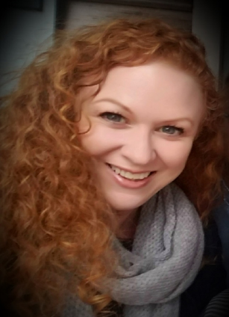**Lisa Wobbe-Veit** is a Clinical Associate Professor at the University of Southern California, Suzanne Dworak-Peck School of Social Work, currently managing Master’s candidates in 18 states as the South Regional Field Director for the school’s Virtual Academic Center (VAC). A USC faculty member since 2011, she played a vital role in the establishment of VAC course material and field procedure. She oversees the field placement experience for all VAC students in her region, ensuring a student’s journey from agency placement to completion is seamless and productive. In addition to administrative functions, Wobbe-Veit has taught courses across the field curriculum including the Virtual Field Practicum, Integrative Learning for Social Work Practice I/ II and served as a field liaison.

Wobbe-Veit’s two decades of experience covers a wide range of needs, including individual, family and group therapy in school, hospital and outpatient settings. Her passion for working with trauma exposed youth led to clinical services roles as a Medical Social Worker, Outpatient Therapist, School Social Worker, Behavioral Specialist and School Based Consultant.  Wobbe-Veit has participated in trauma response within her various positions. As a Parkland resident and parent, she most recently has served as a consultant following the tragic mass shooting in February 2018.

Wobbe-Veit earned her MSW at Washington University’s Brown School of Social Work with a dual concentration in Mental Health and Children & Families with a Specialization in Family Therapy. She earned her BS from the University of Missouri- Columbia in Human Development and Family Studies with an emphasis in Child Life.

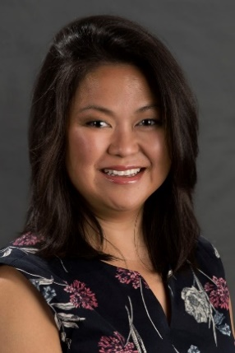**Vivien Villaverde** is a Clinical Associate Professor in the Field Education Department of the University of Southern California Suzanne Dworak-Peck School of Social Work. She graduated from Columbia University School of Social Work with a Master of Science degree in Social Work. She is a Licensed Clinical Social Worker in the state of California and has a California Pupil Personnel Services Credential. She worked as a Psychiatric Social Worker within the Los Angeles Unified School District for more than nine years where she gained valuable experience and expertise in coordinated collaboration and capacity building to address student wellness.  Currently, Prof. Villaverde is the Teaching Institution (TI) Coordinator responsible for developing large scale community partnerships. She assists organizations and agencies in elevating the quality of MSW training in the field and supports innovative collaboration and capacity building. Majority of these consultations are with educational organizations and settings where she strategically facilitated the introduction of the Social Work profession and in building the infrastructure to increase social work services within schools.

In addition, Professor Villaverde is a member of the Treatment and Services Adaptation Center for Schools providing consultation and training on trauma informed interventions, disaster/crisis response and trauma-responsive program development. She has extensive background in multi-systems collaboration and education systems change. Her expertise includes training and consultation with school districts in trauma-responsive transformation including program development, EBP training, and policy development. Prof. Villaverde is engaged in the same work internationally in South Korea and the Republic of the Philippines. In addition, she uses the “Social Responses to the Human Impacts of Climate Change” Grand Challenge as a framework in her disaster response planning work in Asia.

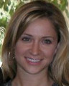**Pamala Vona,** MA, is currently the Program Manager for the Treatment and Services Adaptation Center for Resiliency, Hope, and Wellness in Schools. She also serves as a liaison to the NCTSN School Committee. Ms. Vona’s interests include understanding how to support the implementation of evidence-based mental health practices in community settings. Specifically, her work has focused on how web-based platforms can support training in and implementation of evidence-based practices in schools.

Professors Wobble-Veit and Villaerde and Ms. Vona’s Pre-conferenceworkshop***, Trauma Informed Practice: PSYCHOLOGICAL FIRST AID (PFA): LISTEN, PROTECT, CONNECT—MODEL & TEACH,*** is skills lab addressing trauma informed practice. It is appropriate for social workers at all skill levels for use with K-12 students. Learning objectives include the following:

* To review types of trauma, prevalence and discuss strategies on how to integrate trauma knowledge into practice
* To enhance understanding of the impacts of trauma in students’ emotional, social and academic functioning
* To understand and implement the components of Psychological First Aid (PSA) to reduce the initial distress caused by traumatic events and to foster short and long-term adaptive functioning.

Psychological First Aid is an evidence-informed approach for assisting children, adolescents, adults, and families in the immediate aftermath of a critical incident, disaster, or trauma. PFA is designed to reduce the initial distress caused by traumatic events and to foster short and long-term adaptive functioning. This skills lab will review types of trauma, prevalence and enhance the understanding of the impacts of trauma in students’ emotional, social and academic functioning. Presenters will review the implementation of PFA in schools, specifically, the U.S. Department of Homeland Security’s “Listen, Protect, Connect—Model & Teach” crisis response strategy. Participants will explore goals of the PFA strategy and discuss when and how PFA can be implemented by schools.

**PRE-CONFERENCE**

**Wednesday, October 24, 2018**

***1:30 p.m. – 4:30 p.m.***

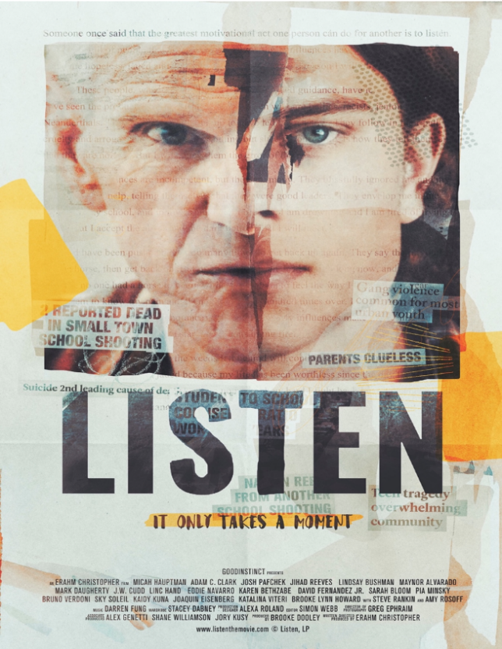

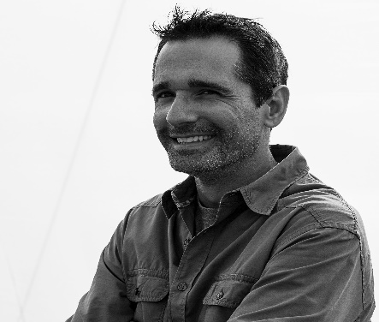**Pre-Conference Presenter: Erahm Christopher** is a filmmaker, speaker and author who bridges social divides using “relevential” films. Christopher has provoked connections, healing and lasting behavior changes in the most dangerous and diverse schools across North America.  He has created content and programming for the federal government, state governments, non-profits, pro athletes, incarcerated youth, health organizations and corporations across the US, Canada and Europe. He has reached over eight million people with his content and has personally presented to over a million people at speaking engagements around the globe.

**Screening of movie, *Listen*, followed by discussion with Erahm Christopher**

In this provocative pre-conference presentation, Erahm Christopher explores how a decade working with youth redefined what “listening” actually means and how the action influences our overall well-being.

In this session participants will:

* Learn how listening has changed with culture shifts throughout history and the depth of the negative impact poor communication practices have in our homes, schools and communities;
* Gain a genuine understanding of the growing mental health problems afflicting our youth;
* Take away clear recommendations to address the current challenges in each school district.

**CONFERENCE**  
**Thursday, October 25, 2018**

8:30 a.m. – 10:30 a.m.

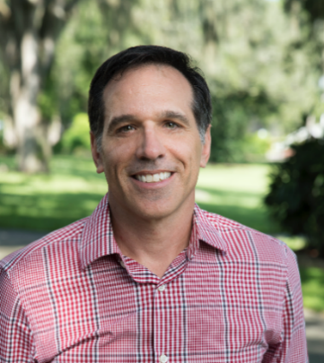**Keynote Speaker: Robert Lucio**, PhD., L.C.S.W., is an Associate Professor of Graduate Social Work in the School of Education and Social Services at Saint Leo University. He has over 18 years of experience working directly with youth “at-risk” of adverse behavioral, academic, and mental health outcomes.  He has taught at undergraduate, masters, and doctoral levels, including courses on research, practice, cultural competence, child development, and family/community violence.  Dr. Lucio has also worked as a school social worker, consulted with school districts to enhance social workers use of evidence informed interventions and has been actively involved school behavioral health.   Dr. Lucio also served as our FASSW president in 2006 and 2007.

Dr. Lucio is experienced at developing models of risk and protective factors in youth, providing trainings on cultural competence, and serving as a national panelist looking at the impact of ethnicity and cultural diversity on educational outcomes for youth with disabilities for the U.S. Department of Education.  His focus is on how risk and protective factors interact to affect child, youth and family cognitive, social, and emotional development.  Findings of his work demonstrate that many of the same risk and protective factors have an impact on the mental health of children in school settings, child development, maternal and child health, and adolescent pregnancy, making the investigation of these factors crucial to the development of interventions to alleviate these concerns.

Dr. Lucio’s keynote presentation, ***Advocacy for Student Wellness, Success, and Safety*** will explore the role of advocacy in supporting student wellness, success, and safety. The art and science of advocacy can work together to create solutions for the challenges which our students are facing today. Social workers are called to address social injustice in every part of a system, from fighting for our clients’ rights through changing the laws and policies that impact the profession’s ability to make long lasting change. In the face of constant threats to our students’ success, social workers are well positioned to not only understand the complex issues facing our schools, but to be leaders in promoting action-oriented solutions. Information covered includes learning how to identify your own learning styles and that of others. Particular emphasis is placed on using this information to increase your communication skills and maximize your ability to communicate with all types of audiences.

Objectives of this presentation include the following:

* Discuss the difference between the art and science of advocacy
* Identify the processes social workers can use to affect change through advocacy
* Present actionable steps school social workers can take to get involved in changing social policies.

**Thursday, October 25, 2018**

**Workshop Sessions A** (10:45 - 12:15)

**A-1*. Thinking Outside the Box: Innovative and Creative Practices for School Based Social Workers*** is a lecture plus interactive exercises and panel discussion workshop on behavior support. It is appropriate for intermediate skill level social workers for use with K-12 students. Learning objectives include the following:

* Identifying trends and needs within the school/community
* Informing and educating staff/students/parents
* Implementing effective interventions to address these needs.

This workshop is a culmination of current, evidence based, effective micro and macro interventions for school social workers to use to engage students, staff and the community

**Presenters:** Lauren Isaac, LCSW, and Mia Terrazas, MSW, School Social Workers, Broward County Schools

**Location:** King Palm

**A-2*. SPARKS (Specialized Professionals Advancing Resources & Knowledge & Skills) - A new approach to student wrap-around services*** is a lecture plus interactive exercises workshop on trauma-informed practice appropriate for social workers at all skill levels for use with K-12 students. The learning objectives are as follows:

* This presentation will aim to provide participants with an introduction to the SPARKS initiative, its concepts, deliverables, model of practice, staff roles, services provided, and its historical foundation
* Participants will explore and be able to identify the interventions utilized for SPARKS
* Presenters will also review the qualitative and quantitative data collected from these interventions during year 1 of the SPARKS initiative.

SPARKS is a Broward County School District initiative, focused on social and emotional wellness, which uses a comprehensive approach to address trauma in students and increase academic performance. The SPARKS initiative is a comprehensive, collaborative-based model that mimics the traditional "client-centered" approach. Come investigate the SPARKLERS' methodology as they take you on a crusade to identifying trauma, solving problems, crisis intervention, increasing parent and community involvement, and shining a light on our greatest assets - our youth!

**Presenters:** Atensia S. Earp, MSW, Registered Clinical Social Work Intern, School Social Worker, and Antoinette Doughty, MSW, BCRP, SPARKS Social Work Team Leader, Broward County Public Schools

**Location:** Queen Palm

**A-3*. Our Transgender Students: A Need for Sensitivity, Support Plan Documents, and a Review of Statewide Work***is a lecture plus interactive exercises workshop addressing violence prevention and trauma informed practice. It is appropriate for social workers at all skill levels for use with K-12 students. Learning objectives include the following:

* Developing empathy and sensitivity towards the experiences of our transgender and gender nonconforming youth
* Understanding the tools and best practices for supporting the unique needs of our transgender and gender nonconforming youth
* Learning about the work that is occurring across the state that is relevant to this population of students.

LGBTQ+ youth have a wealth of unique needs, particularly due to the vast identities and backgrounds represented within the community. Often they do not receive the appropriate school-based counseling and support that is responsive to these needs. More so, our transgender and gender non-conforming students do not receive sufficient support even as school districts begin to implement LGBTQ+ best practices. As a result, this community experiences higher rates of unhappiness, drug use, dropping out of school, truancy, suicide, harassment, and family abandonment. This session will provide the appropriate tools and support to equip school-based professionals to specifically support their transgender and gender non-conforming youth to feel empowered and be resilient.

**Presenters:** De Palazzo, Safe Schools Director, and Ian Siljestrom, Central Florida Safe and Healthy Schools Coordinator, Equality Florida

**Location:** Royal Palm 2

**A-4. *Using the Art and Science of Advocacy to promote student success (Follow Up)*** a lecture plus interactive exercises workshop addressing violence prevention. It is appropriate for social workers at all skill levels for use with K-12 students. Learning objectives include the following:

* Continue discussions on the art and science of advocacy
* Discuss potential barriers in advocating for student wellness, success, and safety
* Discuss potential solutions in advocating for student wellness, success, and safety.

Dr. Lucio will continue his discussion of using advocacy to support student wellness, success, and safety and will be available for questions.

**Presenter: Robert Lucio**, PhD., L.C.S.W., Associate Professor of Graduate Social Work in the School of Education and Social Services, Saint Leo University

**Location:** Royal Palm 1

**Thursday, October 25, 2018**

**Workshop Sessions B** (2:15 – 3:45)

**B-1. *An Interdisciplinary Approach to Trauma in The School System*** is panel discussion on trauma informed practice. It is appropriate for administrative social workers at the intermediate skill levels. Learning objectives include the following:

* Participants will learn current trends in trauma among children and teens which are impacting learning in the school community
* Participants will demonstrate an understanding for trauma-informed care models being utilized in the school system to combat the effects of trauma on learning and student development
* Participants will develop an understanding of the benefits for an interdisciplinary approach to address traumatic incidences in the school system.

The panel presentation will have an educator to examine the tools, resources, and role of the teacher in the classroom; a School Social Worker who will provide an overview of the crisis response process; and there will be discussion on the School Resource Officers’ (SRO) role.

**Presenters:** Courtney Wiest MSW, Ed.D., Associate Director of Graduate Social Work and Cindy Lee LCSW Ph.D., Director of Graduate Social Work, Saint Leo University

**Location:** Royal Palm 1

**B-2*. Sanford ‘Harmony” and “Inspire”: Creating a positive school wide culture*** is a lecture plus interactive exercises workshop addressing behavior support, violence prevention, trauma informed practice and professional self-care. It is appropriate for social workers at the all skill levels for use with K-12 students. Learning objectives include the following:

* Participants will learn specific activities and lessons designed to create positive learning cultures within elementary and middle school settings
* Participants will acquire skills to provide effective small group interventions using Sanford Harmony and to train classroom teachers in the use of Sanford Harmony SEL lessons
* Participants will learn to access 83 professional development online modules and select specific topics for use within their particular school settings.

Participants will engage in interactive learning, receive access to Social Emotional Learning Tool Kits comprised of books, games and lessons for small groups, pre-K-6th grade, and access to 83 online modules for professional development for yourself, educational colleagues and parents. All of this is at no cost to participants through philanthropist Denny Sanford. Bring your lap top.

**Presenters:** Barbara Barry, Doctor of Ministry, Fl. Certified School Counselor, Sanford Harmony and Inspire Developer and Trainer, Nova Southeastern University and Judge Rick Roach, Sanford Harmony and Inspire Coordinator, Developer, and Trainer for the State of Florida, Nova Southeastern University

**Location:** Royal Palm 2

**B-3*. WOWW: What Works Keeps on Working: Several Years with the WOWW Program*** is a lecture plus interactive behavior support workshop appropriate for social workers at all skill levels for use with K-12 students. The learning objectives are as follows:

* Participants will become familiar with the WOWW program for use in the schools and become familiar the steps necessary for implementing the program with a teacher and classroom
* Participants will become familiar with specific Solution Focused Counseling concepts and skills needed for being an effective WOWW Coach
* Participants will become familiar with observation, feedback and scaling techniques important for use with the WOWW program and be able to utilize pre and post-test measures to assess and demonstrate progress.

The WOWW program is an innovative classroom intervention approach created by Lee Shilts and Insoo Kim Berg and is based on Solution-Focused Counseling techniques. It is designed to enhance the climate and functioning of a classroom and its students, promoting both academic and social success. This presentation will discuss the process for implementing the program and tips for success. A simple method of assessing progress will be offered and several years of data will be reviewed.

**Presenters:** Richard Strickland, LCSW and Kathy "Nikki" Counce, MSW, School Social Workers, Hillsborough County Public Schools

**Location:** King Palm

**B-4. Anxiety in Schools: The Role of School Clinicians in Assessment, Treatment, and Support of Anxious Students** is a presentation designed to help school based personnel recognize anxiety symptoms and provide resources to address academic and social impairment associated with anxiety. Anxiety disorders represent a pervasive and impairing cluster of conditions among school-age youth. As a whole, symptoms of anxiety disorders – including separation anxiety, social phobia, school refusal, health anxiety and OCD – are responsible for a significant proportion of school absenteeism, school nurse utilization, virtual and Hospital-Homebound service utilization, and behavioral issues (i.e., disciplinary referrals, ISS/OSS, etc.). Unfortunately, despite increasing pressure from mandates and district policies for school personnel to address student mental health issues, the majority of school clinicians are overwhelmed and under-supported in these efforts. This presentation will provide warning signs of the most common anxiety disorders found in school-age youth, multiple evidence-based techniques appropriate for addressing anxiety symptoms within classroom/school settings, and several community and organizational resources supporting anxious students and their families.

In this session participants will be able to:

1. List behavioral patterns associated with various anxiety disorders common in school-age youth.
2. Demonstrate multiple evidence-based strategies appropriate for addressing anxiety symptoms within classroom/school settings.
3. List several community and organizational resources supporting anxious students and their families.

**Presenter**: Joshua Nadeau, Ph.D., Licensed Psychologist; Clinical Director, Rogers Behavioral Health – Tampa

**Location:** Queen Palm

**B-5*. Administrators Roundtable Discussion*** includes District Administrators and Supervisors

**Location:** Captiva

**Thursday, October 25, 2018**

**Workshop Sessions C**

**4:00 - 4:45 *Joint Regional Workshop*** will be led by FASSW President, Karie Johnston, MSW, LCSW

**Location:** Royal Palm 3

**4:45 - 5:50 *Separate Regional Workshops***

**C-1.** **Region I** (Royal Palm 1)

(Bay, Calhoun, Escambia, Franklin, Gadsden, Gulf, Holmes, Jackson, Jefferson, Leon, Liberty, Madison, Okaloosa, Santa Rosa, Taylor, Wakulla, Walton, Washington)

**C-2.** **Region II** (Royal Palm 3)

(Alachua, Baker, Bradford, Citrus, Clay, Columbia, Dixie, Duval, Flagler, Gilchrist, Hamilton, Lafayette, Levy, Marion, Nassau, Putnam, St. Johns, Suwannee, Union)

**C-3. Region III** (Royal Palm 2)

(Brevard, Indian River, Lake, Okeechobee, Orange, Osceola, St. Lucie,

Seminole, Sumter, Volusia)

**C-4.** **Region IV** (King Palm)

(Charlotte, DeSoto, Glades, Hardee, Hernando, Highlands, Hillsborough, Lee, Manatee, Pasco, Pinellas, Polk, Sarasota)

**C-5. Region V** (Queen Palm)

(Broward, Collier, Dade, Hendry, Martin Monroe, Palm Beach)

**Friday, October 26, 2018**

**Workshop Sessions D** (8:30 – 10:00)

**D-1*. Ethical Considerations in School Social Work (Part 1)*** is a 3-hour workshop addressing professional ethics issues for social workers, which meets the requirements for mandatory continuing education for clinical social worker license renewal. Learning objectives are as follows:

* Learn about the revisions to the NASW *Code of Ethics* and the rationale for the changes.
* Explore ethical dilemmas relevant to school settings.
* Utilizing school-oriented scenarios, apply the NASW Code of Ethics in decision-making.

On August 4, 2017, the NASW Delegate Assembly approved the most substantive revision to the NASW Code of Ethics since 1996. The recently revised National Association Code of Ethics went into effect on January 1, 2018. This workshop provides an opportunity for participants to understand how these significant changes impact the profession and practice. In addition to providing more clarity about the complex ethical issues that arise with the use of various forms of technology, this session will explore common ethical dilemmas that arise in school environments. Ultimately the NASW Code of Ethics offers a set of values, principles, and standards to guide decision-making and everyday professional conduct of social workers.

**Presenter:** Carol Campbell Edwards, MSW, LCSW, NASW Florida, President; Assistant Teaching Professor, Florida State University, College of Social Work

**Location:** Captiva

**D-2*. Implementing a culture of evidence informed decision making in school social work*** is a lecture plus interactive exercises workshop on evidence-informed decision making. It is appropriate for social workers at all skill levels for use with students K-12. Learning objectives include the following:

* Identify a prospective framework for data engagement and usage among school social workers
* Review of pilot data from social workers on their perceptions of the application of the Data Engagement Framework
* Apply findings in discussion for translation into practical application for school social workers.

This presentation will discuss a Data Engagement Framework which looks at the steps necessary for school social workers to utilize data for evidence informed decision making. These steps include: (1) having the right data, which includes risk and protective factors predictive of school success, (2) having access to the data in a format that is easy to access, view and understand, (3) knowing how to interpret the results and what they mean, (4) identifying the context and possible causes for the concern, (5) taking action through employing knowledge, resources, and key interventions to address the concern, and (6) evaluating the impact of the interventions and making any necessary modifications to the intervention plan. We will then explore school social workers perceptions of the application of the Data Engagement Framework within one central Florida county, with an emphasis on the practical application to the field of school social work.

**Presenters:** Robert Lucio, PhD, LCSW andMichael Campbell, Associate Professors, Saint Leo University

**Location:** Royal Palm 2

**D-3*. Educational Supports for Youth in Out of Home Placements*** is a lecture plus interactive exercises workshop addressing trauma informed practice. It is appropriate for social workers at the intermediate level for use with K-12 students. The learning objectives are as follows:

* Participants will understand the intersection of ESSA and Child Welfare legislation on student success
* Participants will learn about school based tiered interventions for youth in out of home care
* Participants will understand the education advocacy support elements for youth in out of home care.

This interactive session will provide evidence-based outcomes for K-12 youth in foster care (out of home care). Participants will learn about the key elements for trauma informed school-based interventions and supports for this vulnerable population.

**Presenters:** Nandranie Busjit Bhalai, M.S.W., Ed.S. in School Counseling, Registered Clinical Social Work Intern; Coordinator, Foster Care Program/Dependency Courts Liaison,Broward County Public Schools

**Location:** Royal 1

**D-4*. Differentiated Behavior: The Effect of Poverty and Trauma on Behavior***is a lecture plus interactive exercises workshop addressing behavior support and trauma informed practice. It is appropriate for social workers at all skill levels for use with elementary level students. Learning objectives include the following:

* Examine how external forces such as poverty, chronic trauma, survival skills and family dynamics impact school behavior
* Increase the clinicians understanding of chronic trauma vs. situational trauma.
* Clinicians attending this workshop will gain practical insight on best practices when addressing behavior concerns in students with low socio-economic status and students exposed to chronic trauma.

**Presenters:** Lynette Judge, MSW, Registered LCSW Intern, School Social Worker, and Shane Reynolds, MA, School Counselor, Hillsborough County Schools.

**Location:** Royal Palm 3

**D-5. *Lessons from Parkland*** is a lecture workshop on trauma informed practice. It is appropriate for social workers at all skill levels for use with students in grades 6-12. Learning objectives include the following:

* Clinicians will learn effects of the school shooting phenomenon that is occurring in schools today
* Clinicians will learn how to help students in 6-12th grade along with staff and administration cope with the effects of school shootings and the threat of school shootings
* Presenters will discuss their experiences at Parkland. Focus will be on the myriad of activities that may be considered when addressing school violence

Attendees will learn effects of school shootings on 6th – 12th graders and how to support students and staff in light of recent incidents of schools.

**Presenters:** Angela Weck, LCSW, Elizabeth Cabrera, MSW, Kim Stone, Ed.S., MSW and Kerry Heideman, LCSW, School Social Workers, Hillsborough County Schools

**Location:** Queen Palm

**Friday, October 26, 2018**

**Workshop Session E** (10:15 – 11:45)

**E-1. *The impact of Domestic Violence on School Age Children*** is a lecture workshop on trauma informed practice. It is appropriate for social workers at the introductory level for use with elementary level students. Learning objectives include the following:

* Identify the signs that a child is being exposed to domestic violence in the home or while in the care of another relative
* Understand how domestic violence impacts a child emotional, socially and in the school setting
* Learn effective ways to provide community resources, direct services and help families rebuild after a parent/relative leaves an abusive relationship.

Each year thousands of families are impacted by domestic violence. However, children have been the " forgotten victims" as they are often overlooked. Children that have been exposed to domestic violence face unique challenges some of which are manifested in the school. This workshop will provide an overview of domestic violence, how it impacts children and community resources to help families rebuild their lives.

**Presenters:** Marissa Mitchell, MSW, School Social Worker, Hillsborough County Schools and

Iana Thomas, Self-employed advocate for women and children

**Location:** Royal Palm 1

**E-2. Who Does the 911 Operator Call? The Value of Self Care for School Social Workers Responding to Trauma for Prolonged Periods** is a lecture plus interactive activities workshop on professional self-care. It is appropriate for social workers at the intermediate skill level working with students K-12. Learning objectives include the following:

* Identify/review the professional benefit of self-care during prolonged trauma service delivery
* Develop a self-care plan (daily, weekly, monthly, as needed)
* Identify strategies for implementation of a self-care plan.

In the course of doing their work, School Social Workers are often confronted by the more challenging aspects of life. Often, they are being asked to “do more with less”, and to work within uncertain funding and restrictive policies. They work with students and families going through tough times and with colleagues, who may also be stressed. Mental health professionals are skilled at recognizing and meeting the needs of the “client”. However, those same professionals may not apply those skills to identify and serve their own needs. Burnout among those in the helping profession is very common and responding for long periods in trauma related situations can accelerate the onset of burnout. Abstract: Practical application of self-care can prove to be difficult for the mental health professional, in large part to due to the intensity and extent of the traumas to which they respond. Often the intellectual understanding of the value of self-inclusion is present; however, the emotional disconnect required to perform at maximum capacity often leads to the lack of application of that intellectual understanding. This presentation highlights the importance of not only understanding the importance of self-care, but the importance of committing to it as a vital part of their work with others.

**Presenter:** Marie English-Arterberry, MSW, Administrator, Employee Assistance Program,

Mental Health Leadership Team, and the Marjory Stoneman Douglas Crisis Response and Recovery Team, Broward County Public Schools.

**Location:** Royal Palm 2

**E-3** ***Institutional Racism in Education: School Social Workers Engaging in Courageous Conversations to Promote the Healing and Achieving of our Students*** is a lecture plus interactive exercises workshop addressing trauma informed practice. It is appropriate for social workers at the intermediate level for use with K-12 students. The learning objectives are as follows:

* School social workers will recognize and acknowledge the presence of Institutional Racism and the impact on their practice
* School Social Workers will acquire knowledge of the link between racism and Adverse Childhood Experiences
* School Social Workers will identify ways to promote the healthy development of students they serve.

School Social Workers have historically recognized the social environment that contributes to the wellbeing and transformation of students. Structural inequalities contribute to anti-learning environments. School social workers as advocates of social justice are called to lead in the change of their school climate to ensure that all students receive equitable support. Engaging in courageous conversations about race is an integral part of school social work practice.

**Presenter:** Marva Furlongue-Laver, MSW, Ph.D. Student, School Social Worker, Broward County Public Schools

**Location:** Queen Palm

**E-4*. Intro to Human Trafficking: It Happens in Our Own Backyards*** is a lecture plus interactive exercises workshop addressing violence prevention and human trafficking. It is appropriate for social workers at the introductory level for use with K-12 students. The learning objectives are as follows:

* Participants will be able to identify forms and scope of human trafficking
* Participants will be able to identify victims of human trafficking and indicators of vulnerable populations
* Participants will be able to identify the needs of victims of human trafficking and access resources to meet those needs

The goal of this training is to increase awareness of the presence of human trafficking. This training was developed by the Pasco County Board of County Commissioners Commission on Human Trafficking. The Commission’s purpose is to: -Promote public awareness of the existence of human trafficking within Pasco County -Establish education programming opportunities for the public and key industries -Advocate strategies, financially and otherwise, to aid rescued victims of human trafficking.

**Presenters:** Emily Gilbert, LCSW, CCTP, Director of Mental Health Community, Presenter for the Pasco Commission on Human Trafficking, Camelot Community Care and Liana Dean, MSW, Chair, Pasco County Commission on Human Trafficking, Community Health Leader, Community Health Activation Team (C.H.A.T), BayCare Behavioral Health **Location:** King Palm

**E-5*. Ethical Considerations in School Social Work (Part 2)*** is the second half of a 3-hour workshop addressing professional ethics issues for social workers, which meets the requirements for mandatory continuing education for clinical social worker license renewal.

Please see Workshop Session **D-1** for additional details about the workshop.

**Presenters:** Carol Campbell Edwards, MSW, LCSW, NASW Florida, President; Assistant Teaching Professor, Florida State University, College of Social Work

**Location:** Captiva

**12:00 – 1:30**  **FASSW Business Luncheon** (Royal Palm 3)





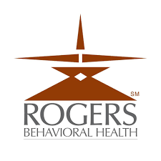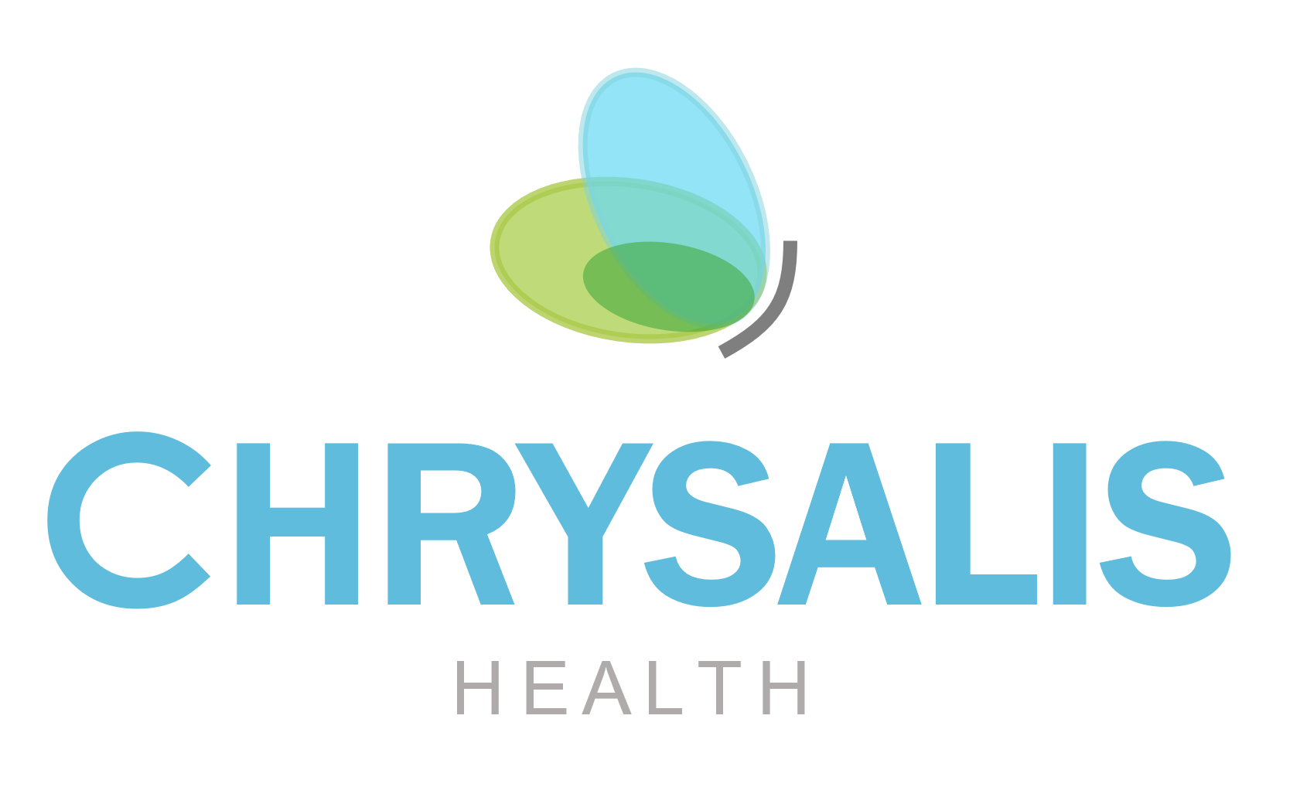

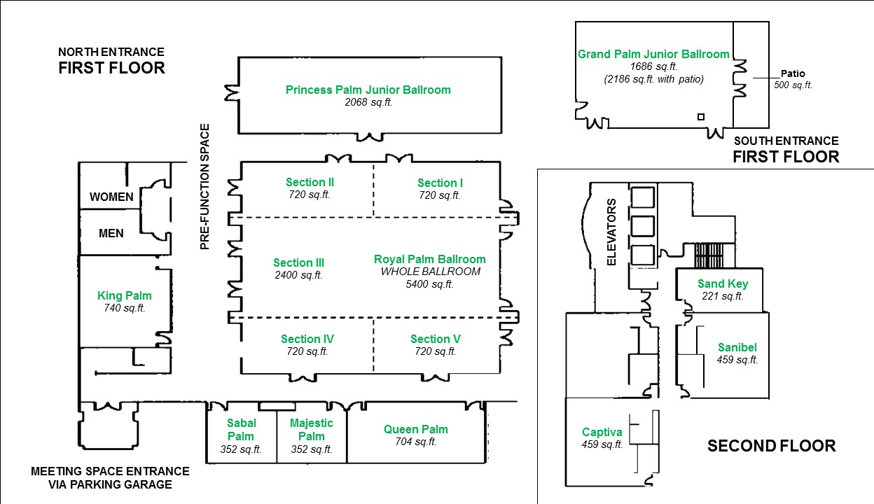

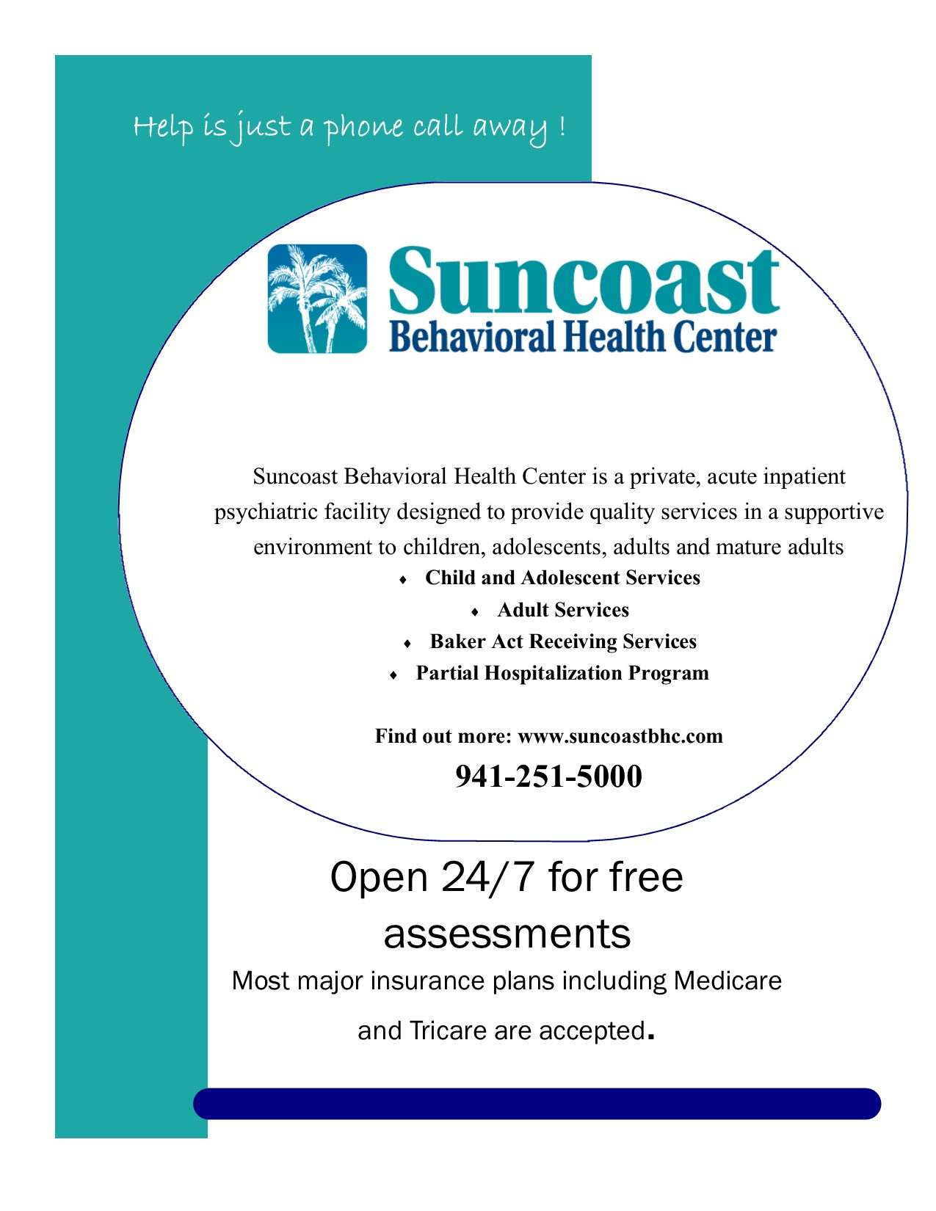

**THANK YOU**

***SPONSORS***

  

***EXHIBITORS and VENDORS***

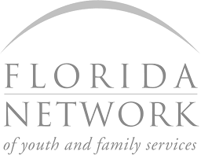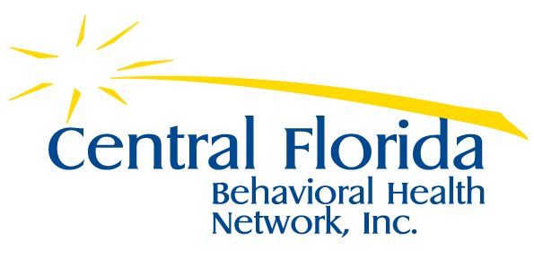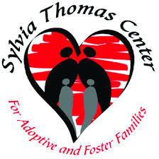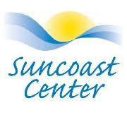

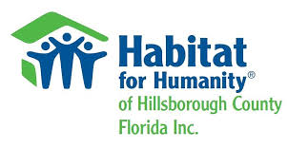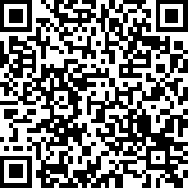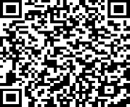 

**Conference Evaluation:**

**Workshop Evaluation:**