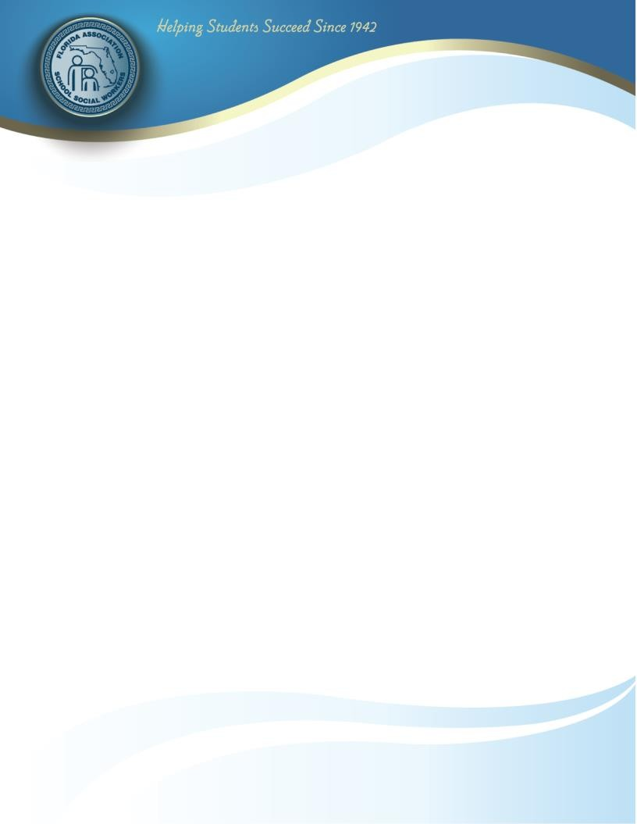

Nomination Form Citizen(s) of the Year

Nominee or Group Mailing Address
City/Zip County

Contact Telephone #

Briefly highlight nominee's/group's outstanding leadership to the community, advocacy on behalf of children and families, or advocacy on behalf of the profession of School Social Work and email together with this nomination form.

Please limit to 1 double-spaced page.

Submitted by Date

Title
Contact Telephone #: Work Cell

Deadline for submission: January 12, 2024

Return application via email to: Karie.Johnston@ocps.net

Any inquires need to be emailed to Karie Johnston, FASSW Immediate Past President

Florida Association of School Social Workers
E-Mail: fassw.president@fassw.org • Website: www.FASSW.org

